Write a Program in C to input a number and find whether the number is exactly divisible by 5 and 7 or not using functions:

>>No return no argument

#include<stdio.h>

#include<conio.h>

void div()

{

printf("divisible");

}

void nodiv()

{

printf("not divisible");

}

void main()

{

int a;

scanf("%d",&a);

if(a%5==0&&a%7==0)

{

div();

}

else

{

nodiv();

}

getch();

}

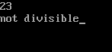

>>No return with argument

#include<stdio.h>

#include<conio.h>

void div(int b)

{

printf("%d",b);

}

void main()

{

int a;

scanf("%d",&a);

div(a);

getch();

}

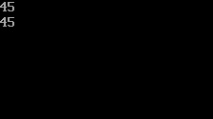

>>Return with no argument

#include<stdio.h>

#include<conio.h>

int div()

{

int a=1;

return a;

}

int nodiv()

{

int a=0;

return a;

}

void main()

{

int n;

char r;

clrscr();

scanf("%d",&n);

if(n%2==0)

{

r=div();

}

else

{

r=nodiv();

}

if(r==1)

{

printf("it is even");

}

else

{

printf("it is odd");

}

getch();

}

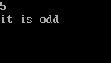

>>Return with argument

#include<stdio.h>

#include<conio.h>

int div(int a,int b)

{

int sum=a+b;

return sum;

}

void main()

{

int a,sum,b;

scanf("%d%d",&a,&b);

sum=div(a,b);

printf("%d",sum);

getch();

}

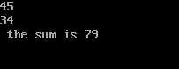

WAP in C to input a number and check whether the number is palindrome or not using function.

#include<stdio.h>

#include<conio.h>

int

r(int a)

{

int rev=0;

while(a!=0)

{

rev=rev\*10;

rev=rev+(a%10);

a=a/10;

}

return rev;

}

void main()

{

int a;

clrscr();

scanf("%d",&a);

if(a==r(a))

{

printf("it is palindrome");

}

else

{

printf("it is not palindrome");

}

getch();

}

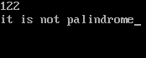

WAP in C to find whether the given number is prime or not using function

#include<stdio.h>

#include<conio.h>

void result(int n)

{

int i,d=0,c;

for(i=2;i<=n;i++)

{

c=n%i;

if(c==0)

{

d++;

}

}

if(d==1)

{

printf("it is prime ");

}

else

{

printf("it is not prime");

}

}

void main()

{

int n;

clrscr();

scanf("%d",&n);

result(n);

getch();

}

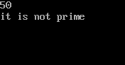

WAP in C to print all prime number less than 500 using function

#include<stdio.h>

#include<conio.h>

void result()

{

int i,d=0,c,n;

for(n=2;n<=500;n++)

{

c=0,d=0;

for(i=1;i<=n;i++)

{

c=n%i;

if(c==0)

{

d++;

}

}

if(d==2)

{

printf("%d is prime\n ",n);

}

}

}

void main()

{

clrscr();

result();

getch();

}

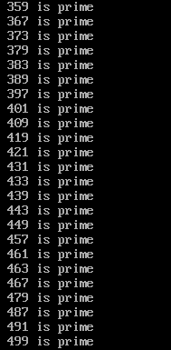

WAP in C to find all the divisor of a given number using functions

#include<stdio.h>

#include<conio.h>

void result(int n)

{

int i,c;

for(i=1;i<=n;i++)

{

c=n%i;

if(c==0)

{

printf("%d is the divisor of %d\n",i,n);

}

}

}

void main()

{

int n;

clrscr();

scanf("%d",&n);

result(n);

getch();

}

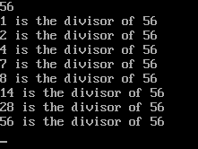

Write a Program in C to input any 10 elements in an array and display them using function. (Passing individual array element).

#include<stdio.h>

#include<conio.h>

void output(int a)

{

printf("%d\n",a);

}

void main()

{

int a[10],i;

clrscr();

printf("enter numbers in array:\n");

for(i=0;i<10;i++)

{

scanf("%d",&a[i]);

}

printf("the numbers are:\n");

for(i=0;i<10;i++)

{

output(a[i]);

}

getch();

}

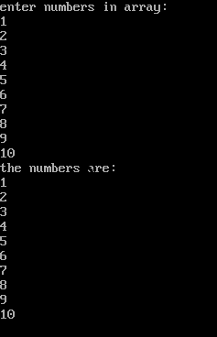

Write a program in c to input any 10 number in an array and sort them in ascending order using function. (Pass Whole array).

#include<stdio.h>

#include<conio.h>

void output(int a[])

{

int i,j,temp;

for(i=0;i<10-1;i++)

{

for(j=i+1;j<10;j++)

{

if(a[i]>a[j])

{

temp=a[i];

a[i]=a[j];

a[j]=temp;

}

}

}

for(i=0;i<10;i++)

{

printf("%d\t",a[i]);

}

}

void main()

{

int a[10],i;

clrscr();

printf("enter numbers in array:\n");

for(i=0;i<10;i++)

{

scanf("%d",&a[i]);

}

printf("the numbers in accending are\n");

output(a);

getch();

}

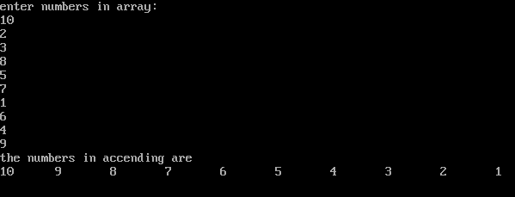

Write a program in c to input any 10 number in an array and sort them in descending order using function. (Pass Whole array).

#include<stdio.h>

#include<conio.h>

void output(int a[])

{

int i,j,temp;

for(i=0;i<10-1;i++)

{

for(j=i+1;j<10;j++)

{

if(a[i]<a[j])

{

temp=a[i];

a[i]=a[j];

a[j]=temp;

}

}

}

for(i=0;i<10;i++)

{

printf("%d\t",a[i]);

}

}

void main()

{

int a[10],i;

clrscr();

printf("enter numbers in array:\n");

for(i=0;i<10;i++)

{

scanf("%d",&a[i]);

}

printf("the numbers in accending are\n");

output(a);

getch();

}

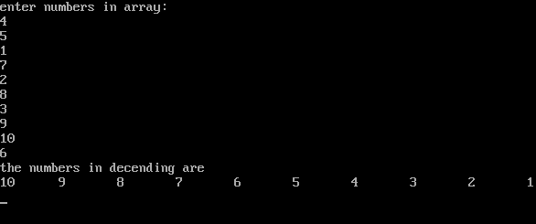

WAP to find the sum of digits entered by the user.

#include <stdio.h>

#include<conio.h>

int sum(int a)

{

int s=0;

if(a>0)

{

s=s+a%10;

s=s+sum(a/10);

}

return s;

}

void main()

{

int num;

printf("enter a number:");

scanf("%d",&num);

printf("\n the sum of digits is %d",sum(num));

getch();

}



WAP in C to ask a number and Power to be calculated for that number

#include <stdio.h>

#include<conio.h>

int result(int a,int b)

{

int re=0;

if(b==1)

{

return a;

}

else

{

re=a\*result(a,b-1);

return re;

}

}

void main()

{

int num,po;

printf("enter a number:");

scanf("%d",&num);

printf("\nenter the power:");

scanf("%d",&po);

printf("\n the result is %d",result(num,po));

getch();

}

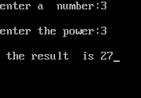

Write a program in C to find factorial of a given number using Recursive Function

#include <stdio.h>

#include<conio.h>

int factorial(int a)

{

int fact=0;

if(a==1)

{

return a;

}

else

{

fact=a\*factorial(a-1);

return fact;

}

}

void main()

{

int num;

printf("enter a number:");

scanf("%d",&num);

printf("\n the factorial is %d",factorial(num));

getch();

}

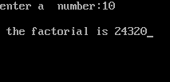

WAP to find the sum of Natural number up to 10 using recursion.

#include <stdio.h>

#include<conio.h>

int sum(int a)

{

int s=0;

if(a==1)

{

return a;

}

else

{

s=a+sum(a-1);

return s;

}

}

void main()

{

int num=10;

clrscr();

printf("\n the sum of 10 natural number is %d",sum(num));

getch();

}

